Due to its layered filesystem, it’s much easier and quicker to share changes with others. It’s also firmly rooted in the command line and is eminently scriptable.

A sandbox is a testing environment that isolates untested code changes and outright experimentation from the production environment or repository,

NGINX is a free, open-source, high-performance HTTP server and reverse proxy, as well as an IMAP/POP3 proxy server. NGINX is known for its high performance, stability, rich feature set, simple configuration, and low resource consumption

If you want to quickly experiment with software without either disrupting your existing setup or going through the hassle of provisioning a VM, Docker can give you a sandbox environment in milliseconds

Docker’s central function is to build, ship, and run software in any location that has Docker.

|  |  |
| --- | --- |
| Command | Purpose |
| docker build | Build a Docker image |
| docker run | Run a Docker image as a container |
| docker commit | Commit a Docker container as an image |
| docker tag | Tag a Docker imag |

Node.js is an open-source, cross-platform JavaScript run-time environment that executes JavaScript code outside of a browser.

WordPress is a free and open-source content management system based on PHP & MySQ

/var/run/docker.sock

You have probably already run containers from the Docker Hub and noticed that some of them need to bind mount the /var/run/docker.sock file. What is this file and why it is sometimes used by containers? Short answer: it’s the unix socket the Docker daemon listens on by default and it can be used to communicate with the daemon from within a container.

#docker run -p 2375:2375 -v /var/run/docker.sock:/var/run/docker.sock sequenceid/socat

You want to run a Docker container in the background as a service.

Solution

Use the -d flag to the docker run command, and use related container-management flags to define the service characteristics

$ docker run -d -i -p 1234:1234 --name daemon ubuntu:14.04 nc -l 1234

Problem: You want to move where Docker stores its data.

Solution:Stop and start the Docker daemon, specifying the new location with the -g flag.

$ dockerd -g /home/dockeruser/mydocker

Occasionally the docker command may not work as you expect. Most often, some aspect of the command-line arguments hasn’t been understood, but occasionally there are more serious setup problems, such as the Docker binary being out of date. In order to diagnose the problem, it can be useful to view the flow of data to and from the Docker daemon you are communicating with.

Solution

Use a traffic snooper to inspect the API calls and craft your own.

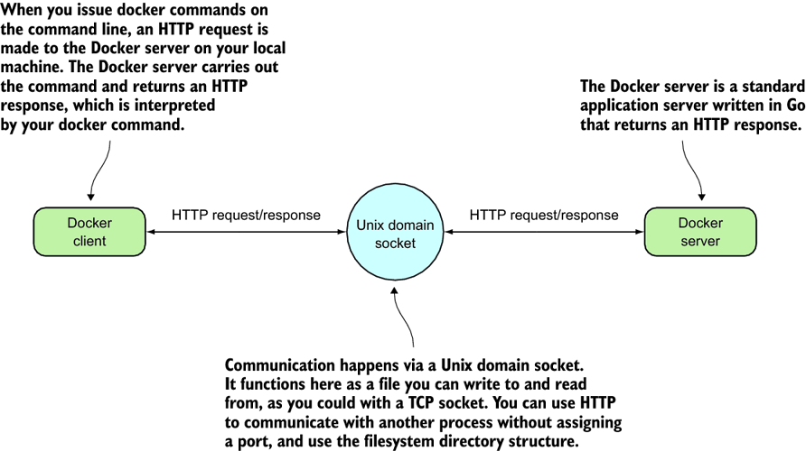

To create this proxy, you’ll use socat.

**SOCAT**

$ socat -v UNIX-LISTEN:/tmp/dockerapi.sock,fork \

UNIX-CONNECT:/var/run/docker.sock &